# **例子**

例子来自这篇Google论文

**Wide & Deep Learning for Recommender Systems**

Heng-Tze Cheng, Levent Koc, Jeremiah Harmsen, Tal Shaked, Tushar Chandra,

Hrishi Aradhye, Glen Anderson, Greg Corrado, Wei Chai, Mustafa Ispir, Rohan Anil,

Zakaria Haque, Lichan Hong, Vihan Jain, Xiaobing Liu, Hemal Shah

Google Inc.

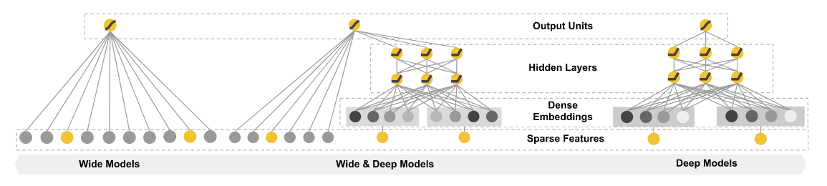

目标是基于5个连续变量(age,education_num, capital_gain, capital_loss, hours_per_week)和 9个类别变量，预测指定人的收入是否高于50,000 dollars

# **数据集描述**

<https://archive.ics.uci.edu/ml/datasets/Census+Income>

|  |  |  |  |  |  |
| --- | --- | --- | --- | --- | --- |
| **Data Set Characteristics:** | Multivariate | **Number of Instances:** | 48842 | **Area:** | Social |
| **Attribute Characteristics:** | Categorical, Integer | **Number of Attributes:** | 14 | **Date Donated** | 1996-05-01 |
| **Associated Tasks:** | Classification | **Missing Values?** | Yes | **Number of Web Hits:** | 196213 |

age: continuous.   
workclass: Private, Self-emp-not-inc, Self-emp-inc, Federal-gov, Local-gov, State-gov, Without-pay, Never-worked.   
fnlwgt: continuous.   
education: Bachelors, Some-college, 11th, HS-grad, Prof-school, Assoc-acdm, Assoc-voc, 9th, 7th-8th, 12th, Masters, 1st-4th, 10th, Doctorate, 5th-6th, Preschool.   
education-num: continuous.   
marital-status: Married-civ-spouse, Divorced, Never-married, Separated, Widowed, Married-spouse-absent, Married-AF-spouse.   
occupation: Tech-support, Craft-repair, Other-service, Sales, Exec-managerial, Prof-specialty, Handlers-cleaners, Machine-op-inspct, Adm-clerical, Farming-fishing, Transport-moving, Priv-house-serv, Protective-serv, Armed-Forces.   
relationship: Wife, Own-child, Husband, Not-in-family, Other-relative, Unmarried.   
race: White, Asian-Pac-Islander, Amer-Indian-Eskimo, Other, Black.   
sex: Female, Male.   
capital-gain: continuous.   
capital-loss: continuous.   
hours-per-week: continuous.   
native-country: United-States, Cambodia, England, Puerto-Rico, Canada, Germany, Outlying-US(Guam-USVI-etc), India, Japan, Greece, South, China, Cuba, Iran, Honduras, Philippines, Italy, Poland, Jamaica, Vietnam, Mexico, Portugal, Ireland, France, Dominican-Republic, Laos, Ecuador, Taiwan, Haiti, Columbia, Hungary, Guatemala, Nicaragua, Scotland, Thailand, Yugoslavia, El-Salvador, Trinadad&Tobago, Peru, Hong, Holand-Netherlands.

# **输出**

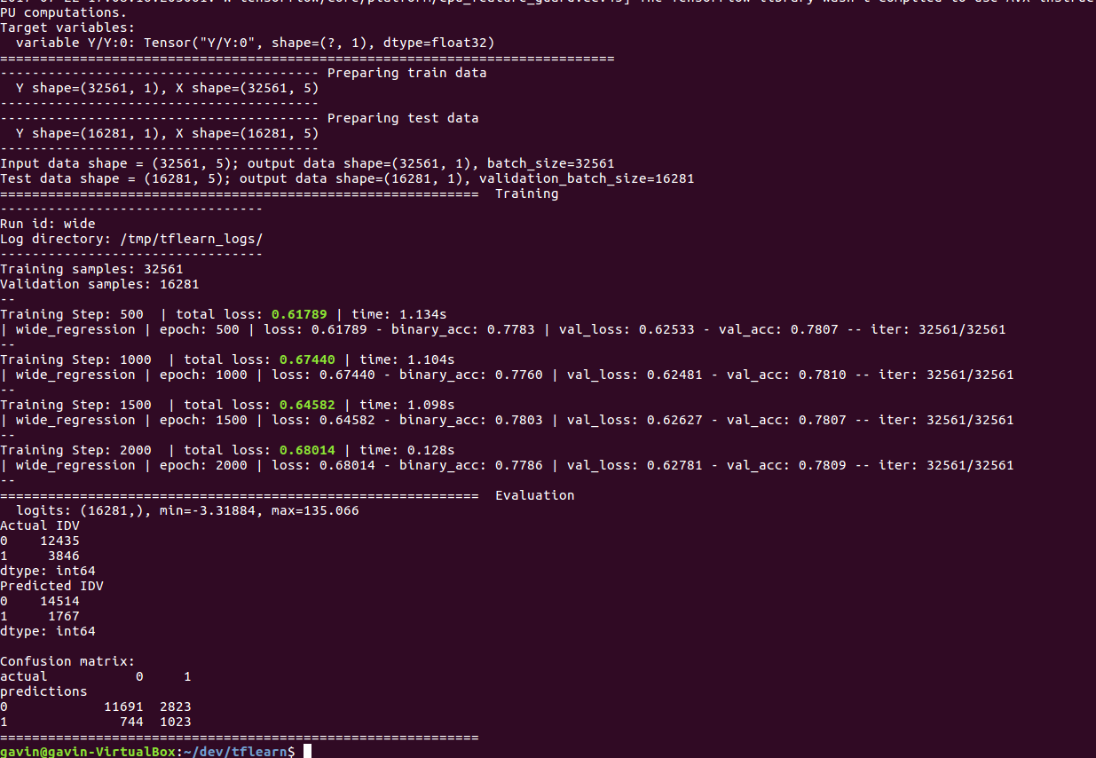

准确率为 (920+11800)/16281 = 78.1%